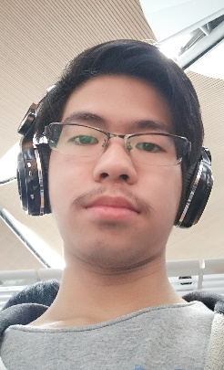**Curriculum Vitae**

Darwin Yo

Email : [darwinyo91@gmail.com](mailto:darwinyo91@gmail.com)

Phone : 0896-2154-9508

Birth Date : 10/07/1997

**Education**

* 2011-2014 HuaQiao University of Culture and Languange

**Languages**

* Great Listener = Indonesian , Japanese ,Chinese , Not Great for (English).
* Great Reader = Indonesian ,Chinese , English ,Barely (Japanese).
* Great Writer= Indonesian ,English, Bad (Chinese, Japanese).
* Great to Speak=Indonesian, Good(Chinese),Bad(English, Japanese).

**Hobbies**

* Look for New Technology, Science
* Look for Latest PC Parts
* Read Programming Books

**Employment Experince**

* 2014 CLC (Children Learning Chinese) – Computer Department (As Data Managent)
* 2014-Till Today Family Business

**Objective**

* Want to Learn as much as I can…
* Be a Great Programmer

**Languages**

* C#,JavaScript,JQuery
* HTML,CSS,BootStrap,ASP.NET
* T-SQL